1. **Agenda:**
   1. Let’s see through App how faulty msgs, which cannot be successfully deserialized, are published to DLT (Dead Letter Topic).
2. 
3. 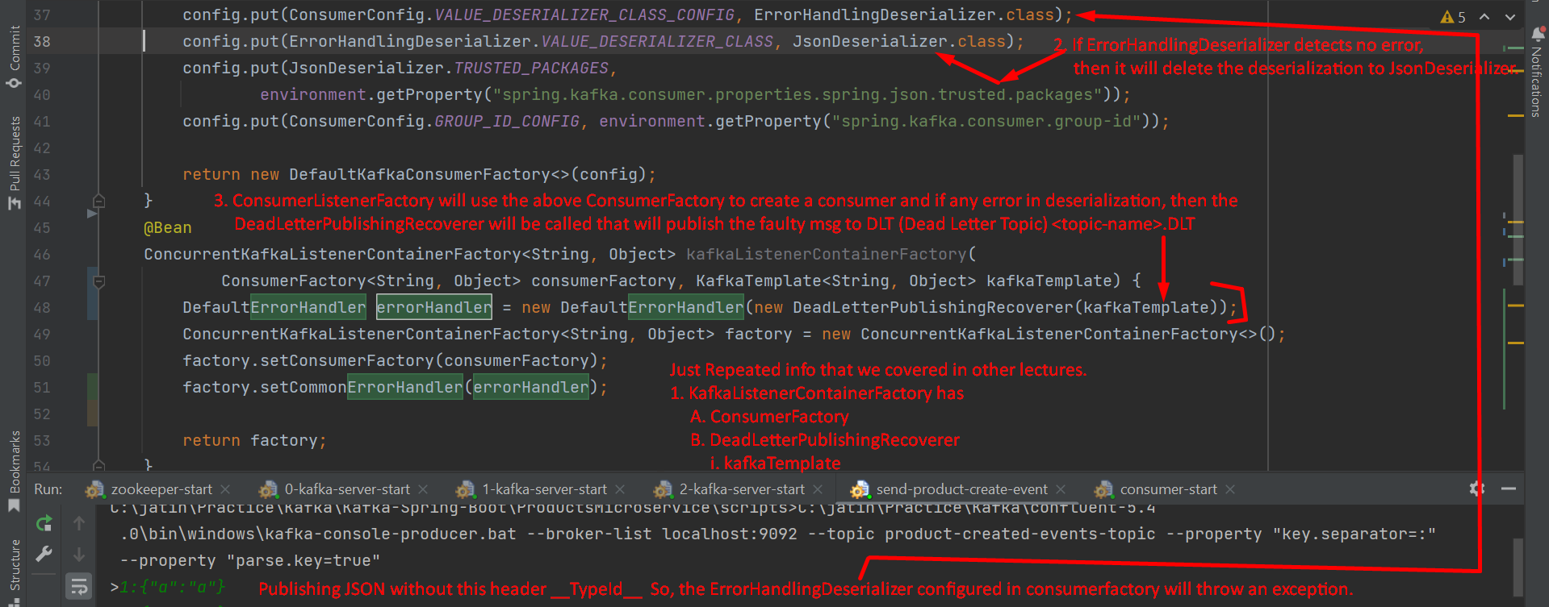
4. 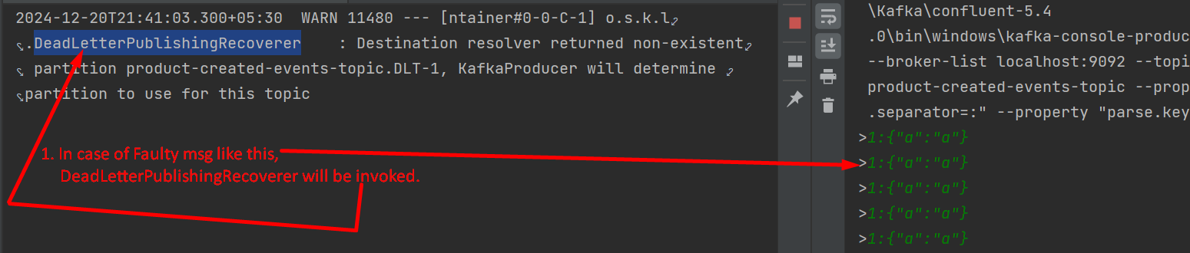
5. **NOTE**: Jatin -> Retry is performed only after msg marshalling is done successfully and exception occurs later on.